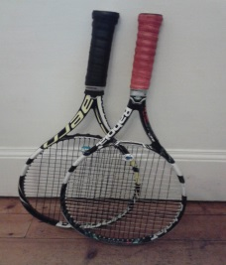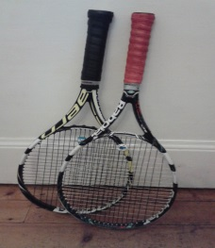
Dean Tennis and Squash Club Summer Holiday Camps 24 Lennox St, Edinburgh, EH4 1QA (http://thedeanclub.co.uk/)
Mon 3rd July - Fri 7th July Inclusive
Mon 10th July- Fri 14th July Inclusive
Mon 17th July - Fri 21 July Inclusive

Dean Tennis and Squash Club will be holding Summer Tennis Camps in 2017. The Tennis camps will be convened and run by head coach, Richard Axton, with the assistance of other coaches

10am – 3pm age group 7-16 (lunch at 12pm (approx 1 hour)
In the event of bad weather and lunch the club house will be used for indoor games including table tennis, pool, table football, quizzes and other games

Cost: Full day/week 10am-3pm £85 members and £105 non members
Part day mornings/week 10am-12noon £40 members and £50 non members
Part day afternoon/week 1pm-3pm £40 members and £50 non members

Tennis camp/s applied for: Week/s Applied for:
Name of child and Date of Birth School Year:
Address: Post Code:
Telephone Number/s : Email contact/s:
Emergency Contacts and number: Relevant medical conditions:

Payment can be made by direct transfer or by cheques made payable to Richard Axton (send to 6 Cameron Crescent Edinburgh EH16 5LB). If more information is needed please contact Richard Axton 07985 799888 or by email embers1000@outlook.com

